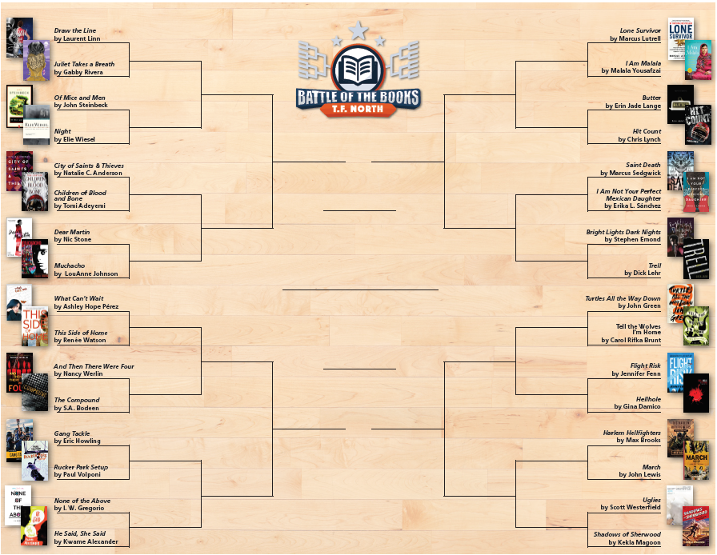

**I Am Not Your Perfect Mexican Daughter**

Turtles All the Way Down

I Am Not Your Perfect Mexican Daughter

I Am Not Your Perfect Mexican Daughter

I Am Not Your Perfect Mexican Daughter

I Am Not Your Perfect Mexican Daughter

He Said, She Said

He Said, She Said

Juliet Takes

a Breath

Uglies

Turtles All the Way Down

I Am Malala

He Said, She Said

This Side of Home

Dear Martin

Juliet Takes a Breath

Uglies

March

Hellhole

Turtles All the Way Down

Bright Lights, Dark Nights

Butter

I Am Malala

He Said, She Said

Gang Tackle

And Then There Were Four

Dear Martin

Children of Blood & Bone

Night

This Side of Home

Juliet Takes a Breath