Name:

Mrs. Bivins

AP Psychology

Date:

Assignment: Unit 1 Guided noted

Directions: While reading units 1 & 2 complete the reading guide below. Type your answers in BLUE. THIS IS AN INDIVIDUAL ASSIGNMNET. YOU ARE NOT ALLOWED TO WORK WITH ANYONE OR SHARE ANSWERS. ALSO ANSWERS SHOULD BE IN YOUR OWN WORDS AND NOT COPIED FROM ANYONE OR THE INTERNET.

Unit 1: Scientific Foundations of Psychology
Psychology is the scientific study of behavior and mental processes. This course examines the history of psychology and psychological theories, contemporary perspectives on psychology, and how psychological research is conducted. As scientists, psychologists collect data and make observations about the ways in which humans and animals behave and think in order to understand behavior and mental processes. Psychologists use a variety of research methods and designs to conduct their research. These tools help them develop psychological theories about behavior and mental processes. To ensure that their results are valid and reliable, psychologists’ research must adhere to strict ethical and procedural guidelines. Historical research is the foundation of the field of psychology and has become the basis for the many subfields within psychology that exist today.

Learning Targets (Mark the box when you pass the Retrieval Practice Quiz on Schoology):
- 1.A- Recognize how philosophical and physiological perspectives shaped the development of psychological thought.
- 1.B- Identify major historical figures in psychology (e.g., Mary Whiton Calkins, Charles Darwin, Dorothea Dix, Sigmund Freud, G. Stanley Hall, William James, Ivan Pavlov, Jean Piaget, Carl Rogers, B. F. Skinner, Margaret Floy Washburn, John B. Watson, Wilhelm Wundt).
- 1.C- Describe and compare different theoretical approaches in explaining behavior (structuralism, functionalism, early behaviorism, Gestalt, psychoanalytic/psychodynamic, humanistic, evolutionary, biological, cognitive, biopsychosocial, and sociocultural.
- 1.D- Recognize the strengths and limitations of applying theories to explain behavior.
- 1.E- Distinguish the different domains of psychology (e.g., biological, clinical, cognitive, counseling, developmental, educational, experimental, industrial–organizational, personality, psychometric, social, positive).
- 1.F- Differentiate types of research with regard to purpose, strengths, and weaknesses (e.g., experiments, correlational studies, survey research, naturalistic observations, case studies, longitudinal studies, cross- sectional studies).
- 1.G- Discuss the value of reliance on operational definitions and measurement in behavioral research.
- 1.H- Identify independent, dependent, confounding, and control variables in experimental designs.
- 1.I- Describe how research design drives the reasonable conclusions that can be drawn (e.g., experiments are useful for determining cause and effect; the use of experimental controls reduces alternative explanations, random assignment is needed to demonstrate cause and effect, correlational research can indicate if there is a relationship or association between two variables but cannot demonstrate cause and effect).
- 1.J- Distinguish between random assignment of participants to conditions in experiments and random selection of participants, primarily in correlational studies and surveys.
- 1.K- Predict the validity of behavioral explanations based on the quality of research design (e.g., confounding variables limit confidence in research conclusions).
- 1.L- Apply basic descriptive statistical concepts, including interpreting and constructing graphs and calculating simple descriptive statistics (e.g., measures of central tendency, variation {range, standard deviation}, correlational coefficient, frequency distribution {normal, bimodal, positive skew, negative skew}).
- 1.M- Distinguish the purposes of descriptive statistics and inferential statistics.
- 1.N- Identify how ethical issues inform and constrain research practices.
- 1.O- Describe how ethical and legal guidelines protect research participants and promote sound ethical practice (those provided by the American Psychological Association, federal regulations, local Institutional Review Board {IRB}, and Institutional Animal Care and Use Committee {IACUC}).

History of Psychology
How did psychology develop into what it is today?
Psychology:

Psychology’s 1st laboratory
Wilhelm Wundt
How have different perspectives influenced the development of psychology as a science?
Psychology’s 1st schools of thought
Structuralism:
Introspection:
Edward Titchener & structuralism

What were some critiques of structuralism?
Why is introspection not a valid measurement?
Functionalism:
William James & functionalism

What two main things is William James known for in psychology?

The Salt Metaphor

How does this relate to the two perspectives?
Psychology’s 1st Women
Mary Whiton Calkins (Mary Was Cheated)
Margaret Floy Washburn
How has psychology changed throughout time?
Psychological Science Develops
Freudian (Psychoanalytic) Psychology
Freudian (Psychoanalytic) Psychology:
Sigmund Freud
Behaviorism
Behaviorism:
John B. Watson
B.F. Skinner
Humanistic Psychology
Humanistic Psychology:
Abraham Maslow

Draw, label, and explain Maslow’s Hierarchy of Needs
Carl Rogers

Psychological Perspectives
How have different perspectives influenced the development of psychology as a science?
Nature: |  | Nurture:
The Nature vs. Nurture Debate
Three Levels of Analysis
Bio-
-psycho-
-social
Perspectives of Ψ
Over-the-Hill
Psychoanalytic (Psychodynamic)
Humanistic
Behavioral
Currently Dominant
Biological
Cognitive

What is cognitive neuroscience?
Rising Stars
Evolutionary

What is behavior genetics?
Social-cultural

What are cross-cultural and gender psychology?
Positive Psychology

Which perspective did it stem from and how is it different?

Psychology’s Perspectives

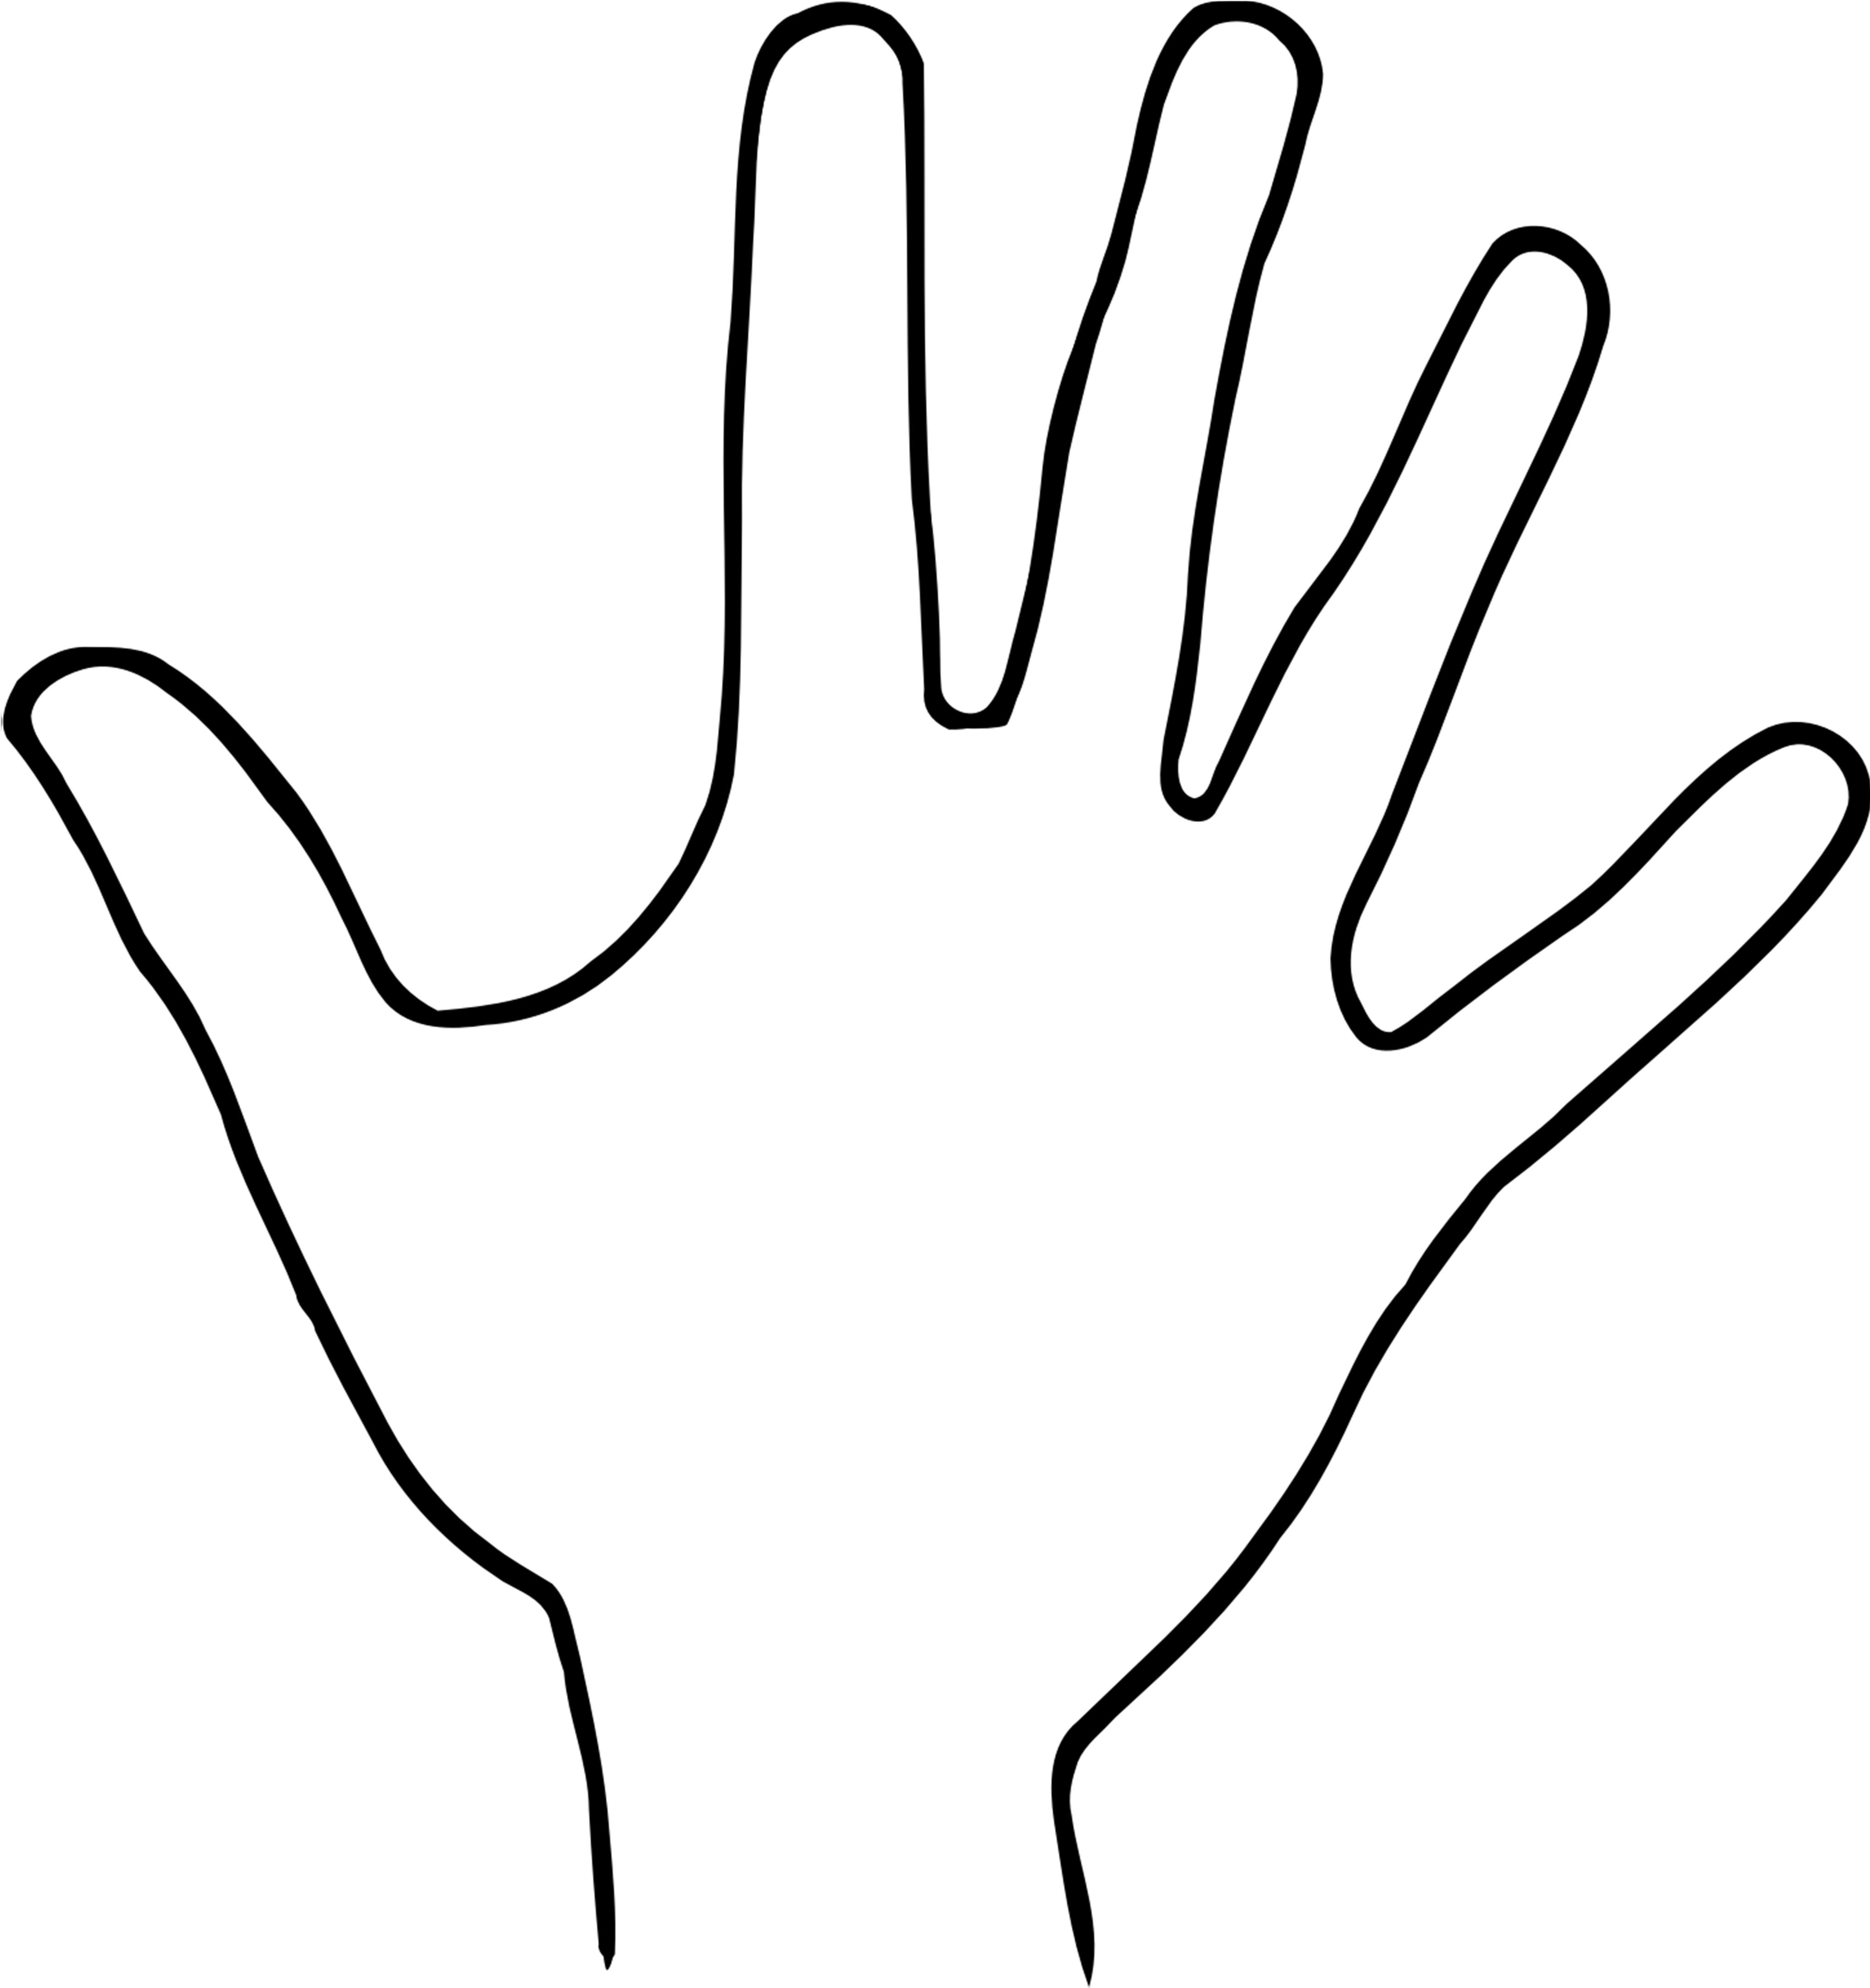

Subfields of Psychology
How is psychology utilized in its career fields?
Ψ’s subfields
Basic Research:
Biological
Developmental
Cognitive
Educational
Personality
Psychometrics
Social
Applied Research:
Industrial-Organizational
Human Factors
Helping Professions:
Counseling
Clinical

How is clinical psychology changing?
Psychiatry is not Ψ
How is psychiatry different from clinical psychology?

Psychological Science and the Scientific Method
How does the methodology of the research affect the outcome of a study?
Errors in Judgment
Hindsight Bias:
Overconfidence:
Perceiving order in random events:
The Scientific Attitude and Critical Thinking
The Scientific Attitude
Theory:
Hypothesis:
Theory |  |  | Hypothesis
Operational Definition:
Operationalize the following:
Stress
Loneliness
Happiness
Why is it important to operationalize within a study?

Outcomes
Reliability:
Validity:
Give an example of how something can be reliable without being valid.
Reliable, but not valid Unreliable and Reliable and valid
hence not valid
Replication:
Why is replication important?

Descriptive Research
Which methods of research are appropriate for the study of different behaviors?
Case Study
Case Study:
Pros |  | Cons
Survey
Survey:
Pros |  | Cons
Wording Effects:
What is an example of wording effects?
Sampling:
Population |  | Sample
Why is it so important to have a representative sample?
Naturalistic Observation
Naturalistic Observation:
Hawthorne Effect:
Pros |  | Cons

Longitudinal Study
Longitudinal Study:
Draw a visual representation of a longitudinal study.
Pros |  |  | Cons
Cross-Sectional Study
Cross-sectional Study:
Draw a visual representation of a cross-sectional study.
Pros |  |  | Cons

Correlation
Correlation:
Positive Correlation |  | Negative Correlation |  | No Correlation
What is the name for these graphs that demonstrate correlation?
Correlational Coefficient:
Simply stated, what does a correlational coefficient tell us?

What range does a correlational coefficient have?

What letter is used to represent correlational coefficient?
Which correlational coefficient has a stronger relationship within the given sets?
-.70 or +.65 |  |  | +.08 or +.33
+.62 or -.89 |  |  | -.54 or +.21
The first thing to look at to determine the value of a correlational coefficient & why:
The second thing to look at to determine the value of a correlational coefficient & why:

Correlation ≠ Causation:
Explain an example of correlation ≠ causation that you find most memorable:
Illusory Correlation:
What’s an example of an illusory correlation?
Regression Toward the Mean:
What’s an example of regression toward the mean?

Experimentation
Elements of Experimentation
Experimental Group:
Control Group:
Experimental Group |  | Control Group
Placebo:
What is a placebo?

Why would an experiment need to use a placebo?
Random Sample/Selection:
Random Assignment:
Random Sample/Selection |  | Random Assignment
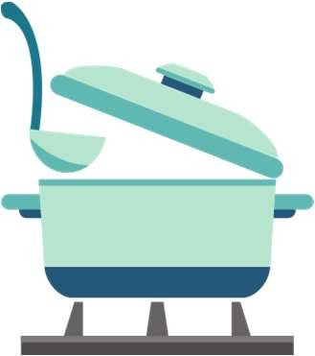
What is the purpose of using either of these methods and how do they help?

When is it appropriate to use these methods within an experiment?

Are these only used in the experimental method?

Independent Variable:
Dependent Variable:
Independent Variable |  | Dependent Variable
Issues in Experimentation
Confounding Variable:
What are some examples of confounding variables?
Participant Bias:
What are some examples of participant bias?
Researcher Bias:
What are some examples of researcher bias?
Placebo Effect:
What negative effects can a placebo have?
Reducing Bias
Single Blind:
Double Blind:
When is it appropriate to use one or the other?
What sets the experimental method apart from the other types of research methods?

Statistical Reasoning
Descriptive Statistics
Descriptive Statistics:
Measures of Central Tendency
Measures of Central Tendency:
Mean:
Median:
Mode:
Which measure of central tendency is most impacted by outliers?
Measures of Variation
Range:
Standard Deviation:
Bell Curve:

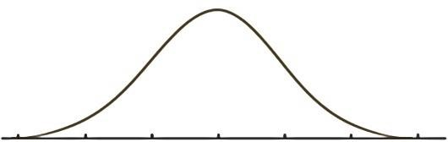

Inferential Statistics
Inferential Statistics:
Statistical Significance:
What does statistical significance mean?

p-value:
What does p-value mean?
Visual Representation of Data
Histogram |  |  | Bar Graph
Bell Curve- Negative Skew |  |  | Bell Curve- Positive Skew
What should you be paying attention to when deciding what type of skew it is?
While we might tend to think these names are swapped, why do these names actually make sense in reference to the data?
Bimodal Distribution
Bimodal Distribution:
Give an example of a bimodal distribution.
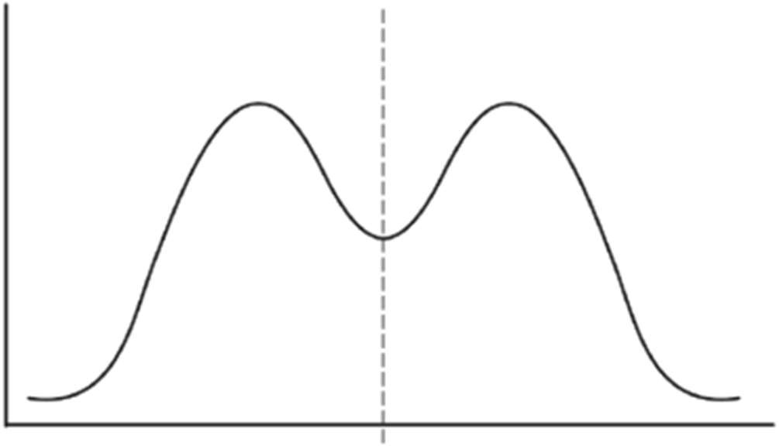

Ethics in Research
How do ethical guidelines impact psychological research?
The Laboratory Setting
Pros |  | Cons
How has psychology been shaped by values?
What impact does psychological science have?
What governing bodies set and regulate guidelines for the ethical treatment of research subjects?
Animal Research
What ethical principles must be followed for animal research?
Human Research
Informed consent
Safety from harm & discomfort
Confidentiality
Debriefing
Created by Melissa Rogers, Cedar Falls High School, Cedar Falls, IA

