Mrs. Bivins Google Classroom Enrollment Instructions
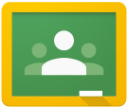
To sign up for my classroom you will need a Gmail email account.

Go to gmail.com and follow the instructions to create an account. Your Gmail email address must include your first and last name. Examples: firstnamelastname, firstname.lastname, firstname_lastname, etc…

Make your password your id number so that you will not forget it.

After you have created a Gmail account you can now sign up for Google Classroom.

To Open Google Classroom you have 2 options:

Option 1: Enter the URL
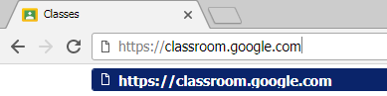

Option 2: Open from Launcher
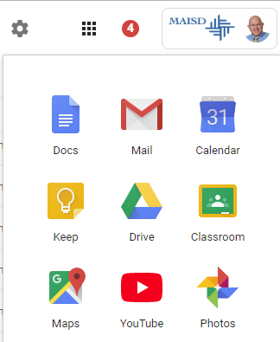

Next pick student as your role.
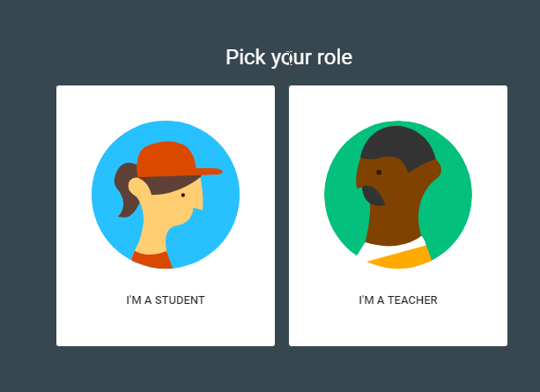

Once you are in google classroom you can now enroll in a class. Select the correct class code from below.

Class & Period | Class Code
AP Language & Composition | 35qovai
AP Psychology | x4s6sqn

You MUST use your real first and last name when creating the account and your MUST have a picture of yourself also. – THIS IS REQUIRED!

After you have enrolled in my classroom, download the google classroom app. You can now have access to my classroom through the app.

You will be submitting your assignments directly to google classroom. Please be sure to familiarize yourself and get comfortable with google classroom this summer! Your assignments can be submitted directly from your google drive.

You can start discussions on the feed that myself and your classmates can respond to. So, if you have a question or a comment about your assignments over the summer, feel free to post to the class discussion feed.

