October Breakfast Menu
2020
EQUAL OPPORTUNITY PROVIDER
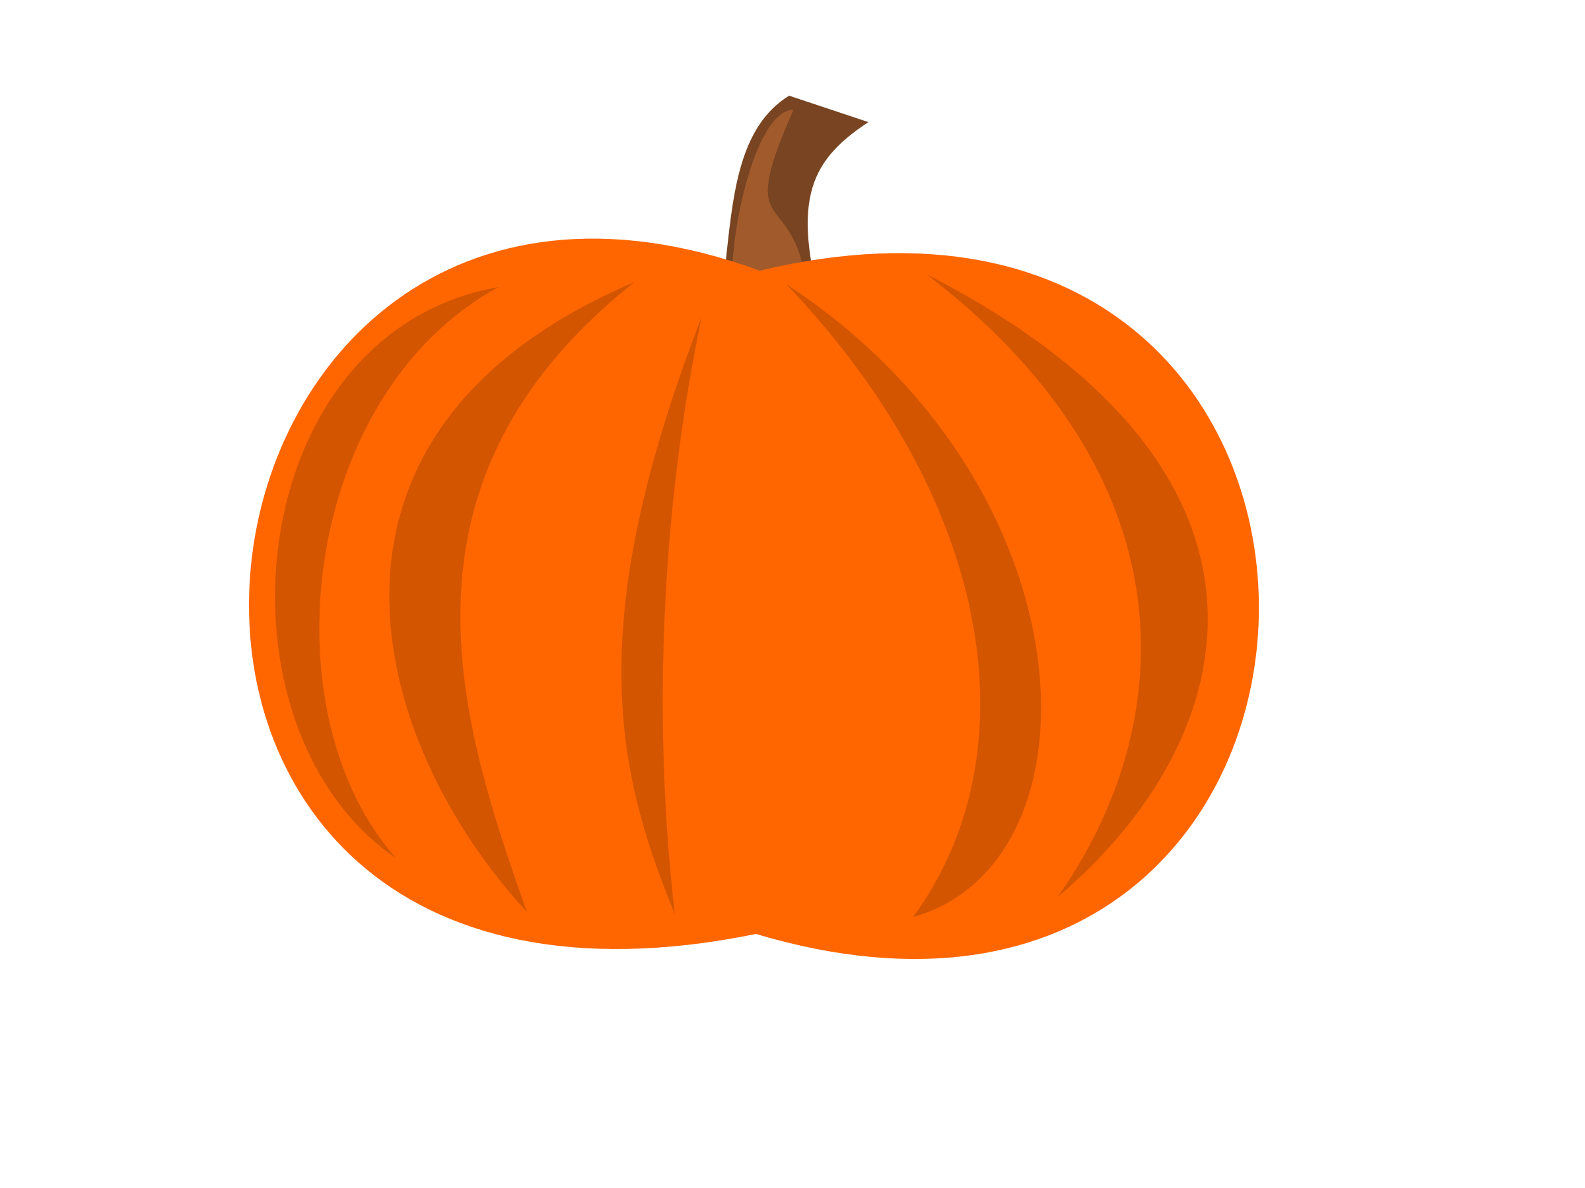
Sunday | Monday | Tuesday | Wednesday | Thursday | Friday | Saturday
 |  |  |  | 1 | 2 | 3
 |  |  |  | Whole grain Chocolate chip Pancake, Syrup, Pear & Milk | Sausage Biscuit with jelly  Orange & Milk
4 | 5 | 6 | 7 | 8 | 9 | 10
 | Original Pancake, Syrup, Apple & Milk | Whole grain Strawberry Pancake, Banana & Milk | Assorted Cereal & Bars, Grapes & Milk | Parent Teacher Conference | NIA
11 | 12 | 13 | 14 | 15 | 16 | 17
 | Columbus Day | Whole Grain Blueberry Waffle, Syrup, Fruit Cup & Milk | Assorted Pop Tart, Apple & Milk | Whole Grain Confetti Pancakes, Pear & Milk | Cinnamon Pretzel stick, Apple & Milk
18 | 19 | 20 | 21 | 22 | 23 | 24
 | Whole Grain Double chocolate muffin, Orange & Milk | Apple Frudel, Banana & Milk | Turkey Sausage pancake bites, Syrup, Banana & Milk | Whole grain Maple Pancake, Syrup, Fruit Cup & Milk | Whole grain Blueberry Muffin, Fruit juice & Milk
25 | 26 | 27 | 28 | 29 | 30 | 31
 | Assorted Cereal & Bars, Grapes & Milk | Original Pancake, Syrup, Apple & Milk | Banana Muffin, Oranges & Milk | Chocolate Chip French Toast, Banana & Milk | Cherry Frudel, Orange & Milk

