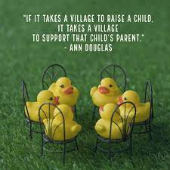  ParentS Group  Join the Aunt Martha’s staff for a bi-weekly support group where parents will have a safe place to vent, ask questions, receive trainings, information, and new ideas on self-care and more. There will be a guest speaker each month. Door prizes and incentives offered.  The parent support group is open to all CCBYS parents and parents in our communities.  Zoom link: https://auntmarthas-org.zoom.us/j/3676447768  Time: 6:00 pm to 7:00 pm  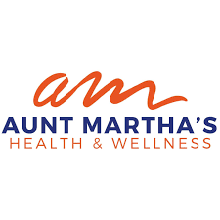 | Parent Support Group  Meetings held on zoom every 1st and 3rd Thursday of the month.  ────  OUR MISSION  Aunt Martha’s Health and Wellness boldly commit to supporting the well-being of our communities, ensuring equity in access, and delivering exceptional care inspired by a culture of innovation.  Aunt Martha’s  23485 Western Park Forest, 60466  708-825-3066  eleonard@auntmarthas.org

