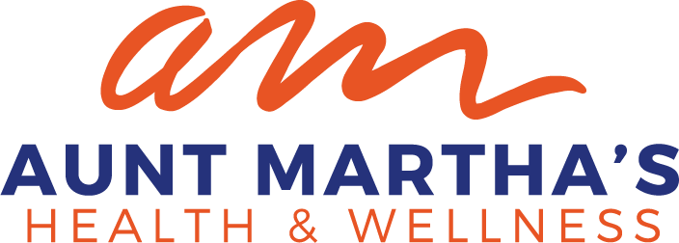

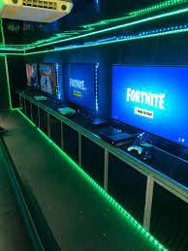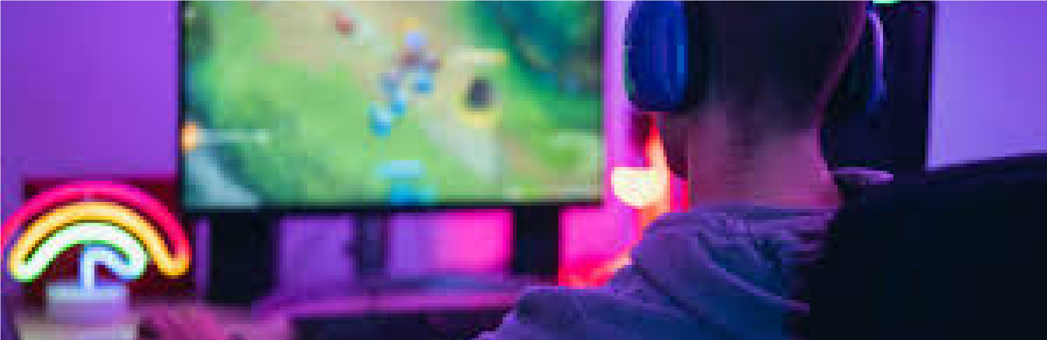

**Video Game Truck**

**& Pizza**

Thursday, April 20th

4:00

pm-6:00pm

**CCBYS Program**

**South Cook**

23485

Western Ave

Park Forest, IL 60466

**Free Event**

:

Open to all participants

**RSVP**

Please contact Ericka Leonard-Whorton

Phone: (708) 210-2241

eleonard@auntmarthas.org

RSVP

by:

April 18, 2023