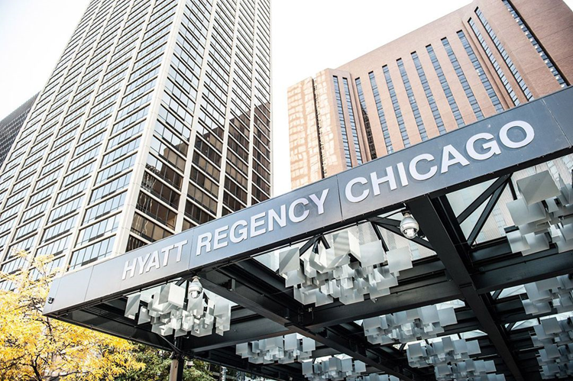  TF North prom  When  May 11, 2018  6:00 pm -10:30 pm  Where  Hyatt Regency Chicago  Crystal Ballroom- 151 E. Wacker Dr. Chicago, IL  FEATURING · Buffet Dinner/Dessert ·  Unlimited Soft Drinks · 2 Photographers · |  |  | Tickets  April 16th – April 20th  $115 per person  - CASH ONLY  - NO REFUNDS  Purchase  @ Bookstore  8:15 am – 3:30 pm  Eligible  Senior 18.5 credits  Junior 15 credits  ALL FINANCIAL Obligations are PAID IN FULL  Guests  Must be approved by  Prom Guest Request Form  Due by April 12th in DEANS Office

