Instructions for Registering Your Child Online

Registration Codes:
To register your child online, parents will need to use their PowerSchool username and password. If you have an account and forgot your username or password go to the PowerSchool webpage located at http://psch.tfd215.org click on the section that reads, Having Trouble Signing In, you will be emailed your username and password.

Parents of Freshmen/Those Who Don’t Have Accounts:
1. Open your Web browser to your school's PowerSchool Parent Portal URL http://psch.tfd215.org. The Parent Sign-In page will appear.
2. Click Create Account. The Create Parent Account page appears.
3. Use the following table to enter information in the Create Parent Account section:

 | Field | Description
 | First Name | Enter your first name.
 | Last Name | Enter your last name.
 | Email | Enter your email address. The email address you enter is used to send you select information, as well as account recovery notices and account changes confirmations. For more information, see Email Notifications.
 | Desired Username | Enter the username you would like to use when signing in to the PowerSchool Parent Portal. The user name must be unique. If you enter a user name that is already in use, you will be prompted to select or enter another user name.
 | Password | Enter the password you would like to use when signing in to the PowerSchool Parent Portal.
Student Name |  |  | Enter the first and last name of the student you want to add to your account.
Access ID |  |  | Enter the unique access ID for the student. The access ID is located on your mailing label  Note: If you do not have this information, contact your school.
Access Password |  |  | Enter the unique access password for the student. The access password is located on your mailing label.  Note: If you do not have this information, contact your school.
Relationship |  |  | Indicate how you are related to the student by choosing the appropriate association from the pop-up menu.

5. After you have created your account for PowerSchool, you will be redirected back to the login page.
6. Once logged in you will see the following screen:

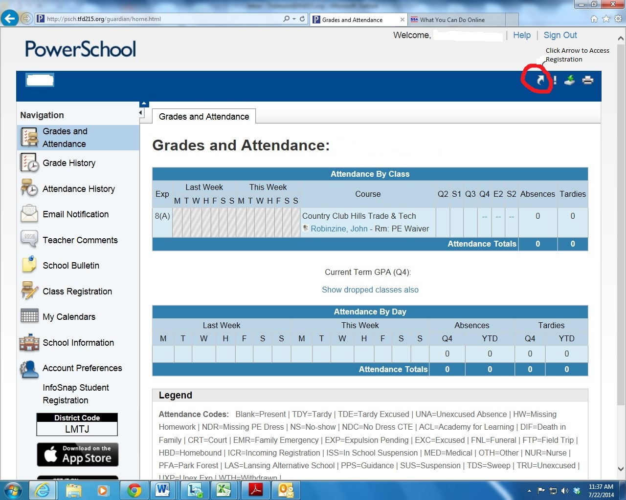

7. In the upper right hand corner you will see an arrow, click this arrow and it will direct you to the registration portal. Please fill-out all forms listed.

PowerSchool Users:
- If you have trouble logging into PowerSchool, click on the ‘Forgot Password’ link and you will be emailed an option to reset your password.
- Once you have logged in you will see the screen listed above, click on the arrow in the upper right-hand corner to access the online registration.

