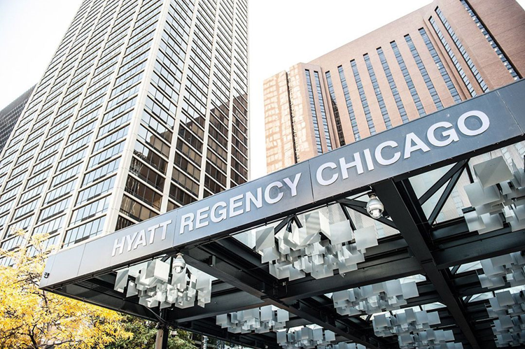  TF North HS  prom  When  Saturday, May 18, 2019  6:00 pm -10:30 pm  Where  Hyatt Regency Chicago  Crystal Ballroom- 151 E. Wacker Dr. Chicago, IL  FEATURING · Buffet: Appetizers/Dinner/Dessert  · Unlimited Soft Drinks & Specialty beverages  · Portrait Photographer · DJ |  |  | Tickets  April 29th – May 3rd  $120 per person  - CASH ONLY  - NO REFUNDS  Purchase  @ Bookstore  8:15 am – 3:30 pm  Eligible  Senior 18.5 credits  Junior 15 credits  ALL FINANCIAL Obligations are PAID IN FULL  Guests  Must be approved by  Prom Guest Request Form before ticket can be purchased  Due by April 17th to DEANS Office

