WE PROUDLY SUPPORT TFN!

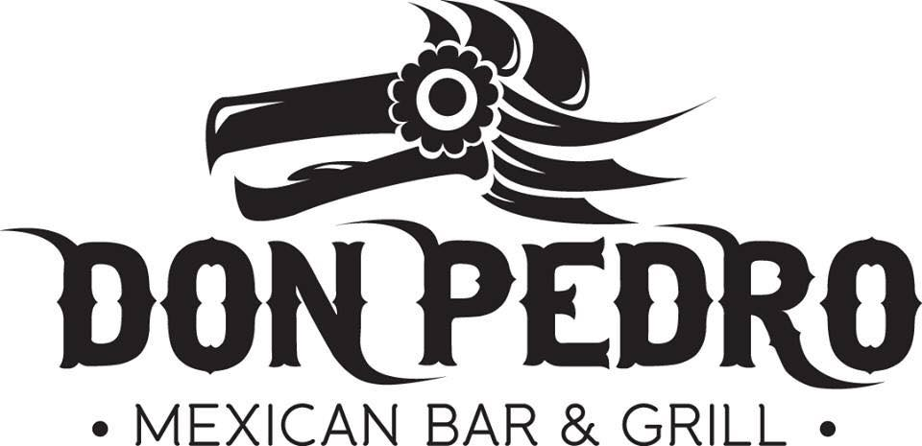

Dine in, Carry Out or have Don Pedro’s
Delivered right to your door on
~ Thursday, February 11, 2016 ~
Simply, present this flyer and Don Pedro will
DONATE 15% of your food sales to the
TFN Visual Arts Club and Rob Paradise Scholarship Fund!
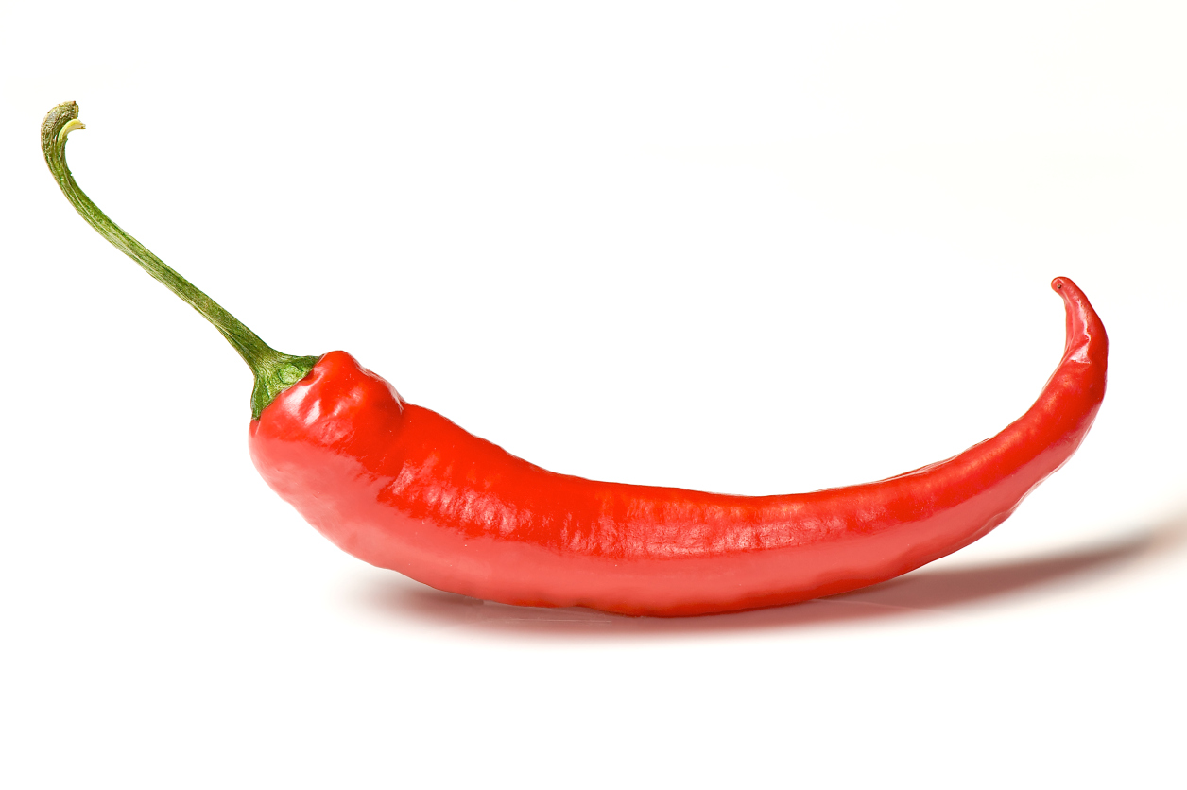

Spread the word ~ tell everyone you know!
316 Torrence Avenue, Calumet City location only.
Call 708.862.7747 to make reservations.
Place a prepaid carry out and/or delivery order using
GrubHub.com, EatStreet.com or Eat24.com
*Delivery Charge of $3 applies to all delivery orders. Delivery area restrictions apply.
Donation is on FOOD sales only. Present this flyer upon ordering. No credit cards taken over the phone.

